

**Lab Terminal # 04**

**Submitted by:** Isha Eman

## **Reg #:** fa21-bcs-046

**Make class and sequence diagram in your mini compiler.**

Sequence diagram

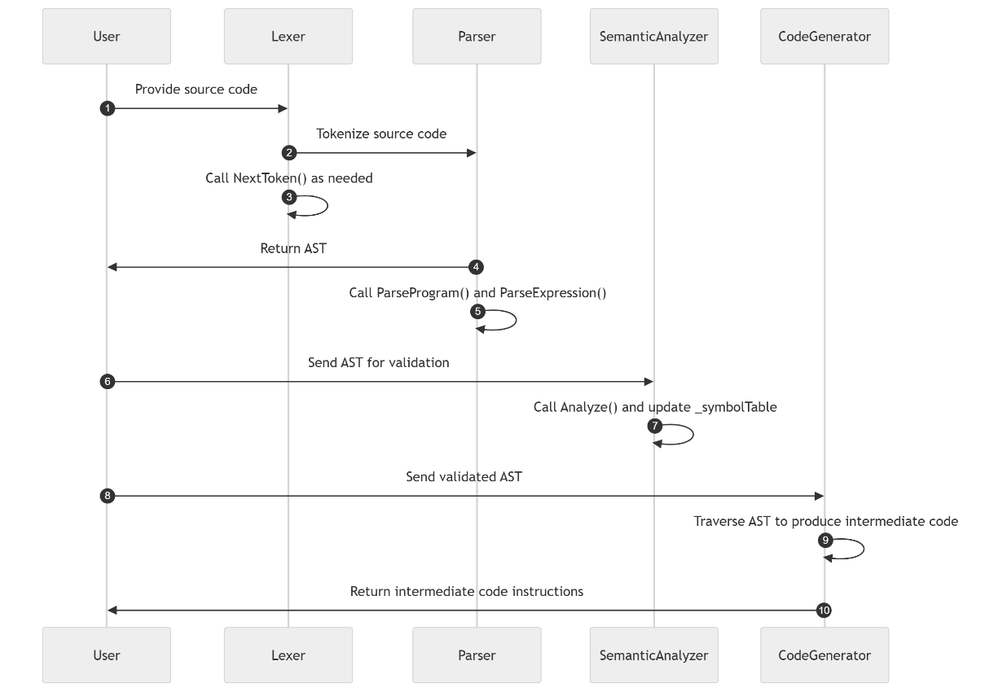

Class Diagram

